**SE LAB WEEK 2**

**Objective:**

1. Pushing multi-folder project into private repository (by student).
2. Students must explore all listed git commands on the multi-folder project in local and remote repository.
3. Students must explore all git commands on given scenario-based question.
4. Students need to make note in observation book and also upload the executed exercise on scenario-based question.

**Task 1:** Pushing multi-folder project into private repository( Note: student take screenshots for upload).

**1. Create a Private Repository on GitHub**

* Go to <https://github.com>
* Click **New repository**
* Give it a name
* Check **Private**
* Click **Create repository**

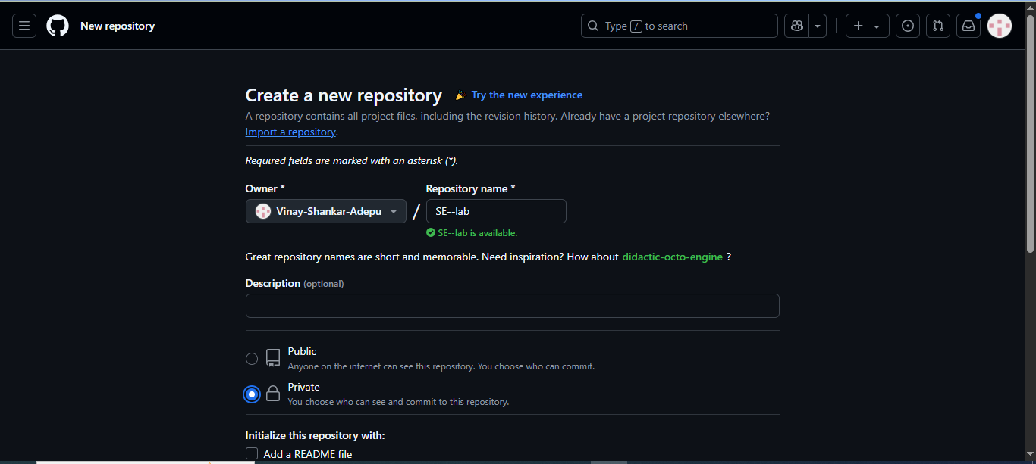

**2. Initialize Git in Your Local Project (if not already done)**

Open a terminal in the **root** of your multi-folder project:

cd /path/to/your/project

**git init**

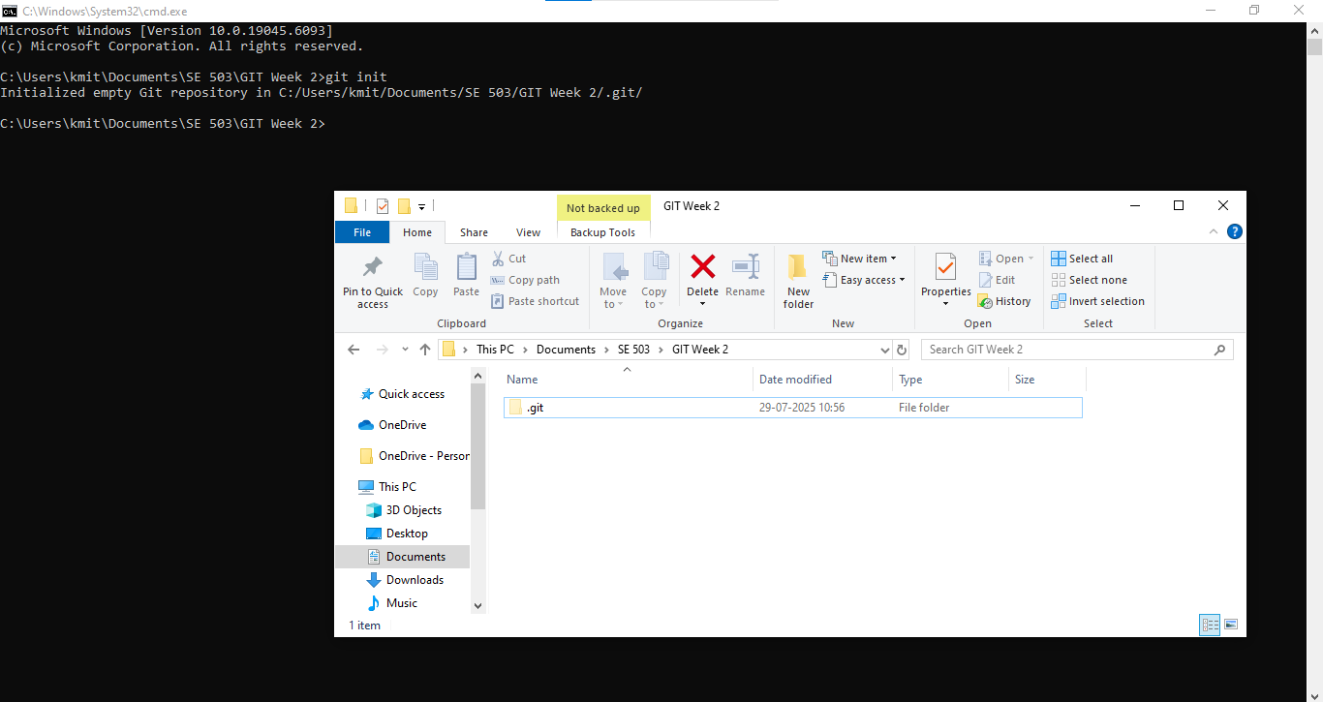

**3. Add the Remote Repository (in bash)**

You’ll see a URL on GitHub after creating the repo. It will look as below , run this command in git bash:

**git remote add origin** [**https://github.com/yourusername/your-private-repo.git**](https://github.com/yourusername/your-private-repo.git)

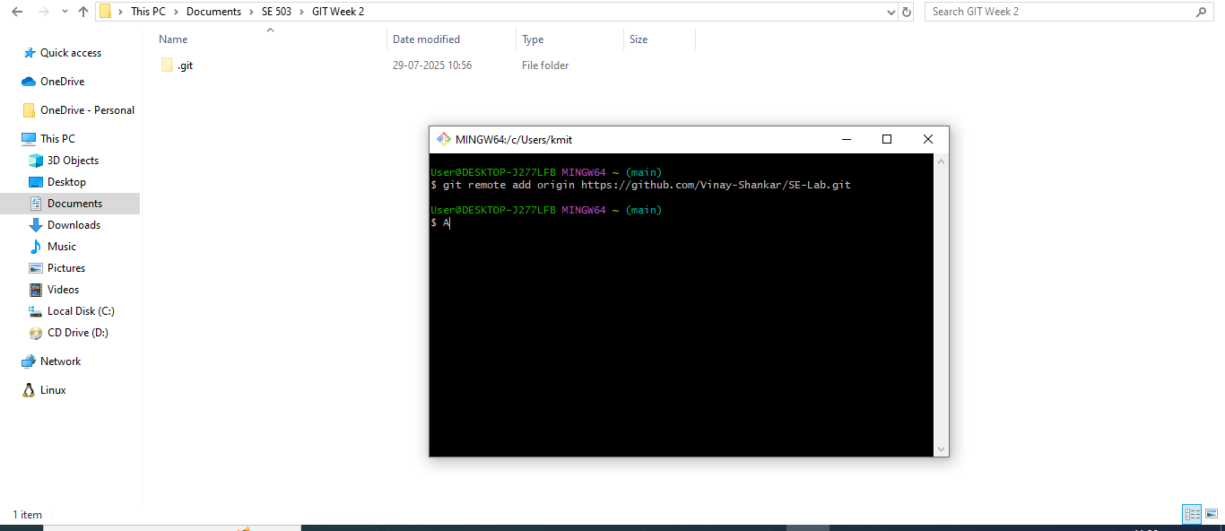

**4. Add and Commit Your Files(in bash)**

**git add .**

**git commit -m "Initial commit"**

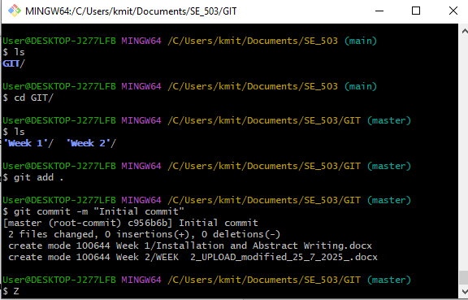

**5. Push to the Private Repository**

If the repo is new and empty, push like this from git bash:

**git push -u origin master**

If you're using the main branch (GitHub default):

**git push -u origin main**

You may be prompted to log in (via username/password or token).

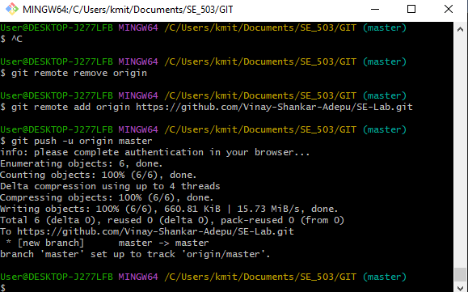

**Task 2:** Students must explore all listed git commands on the multi-folder project in local and remote repository.

1. **Git Commands:**

* git version : The command git version is used to check the version of git.

**git --version**

* git config: Configures Git settings. Commonly used to set up user information

**git config --global user.name "Your Name"**

**git config --global user.email "youremail@example.com"**

* **git config --list**: Displays all the Git configurations for the current user.

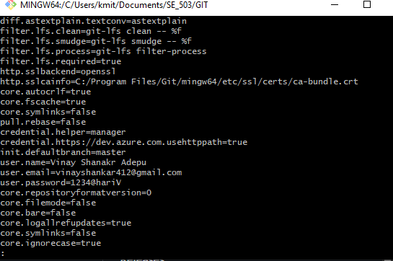

1. **Repository Management**

* **git init**: Initializes a new Git repository in the current directory

**git init**



* **git clone**: Creates a copy of an existing Git repository from a remote source (e.g., GitHub) to your local machine

**git clone** [**https://github.com/username/repository.git**](https://github.com/username/repository.git)

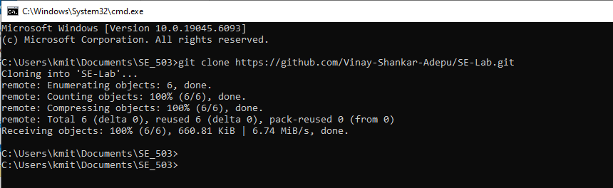

* **git remote –v :** To see the remote repository that is connected to your local repository

**git remote –v**

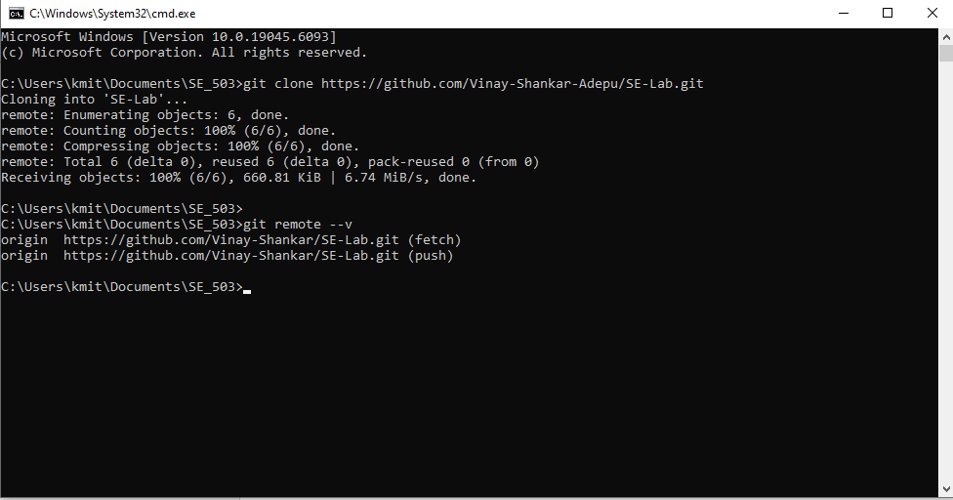

* **git remote add :** To add a new remote repository to your local repository

**git remote add origin** [**https://github.com/username/repository.git**](https://github.com/username/repository.git)

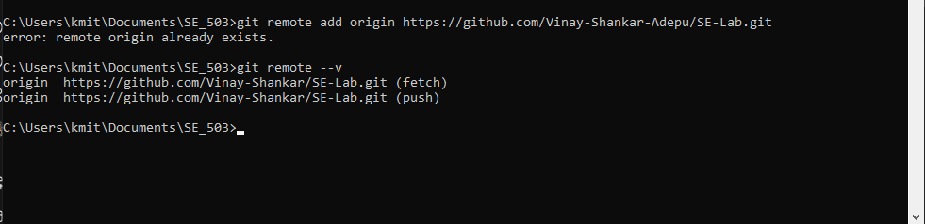

**Scenario based questions on basic git commands**

1. You made changes to one file in the above project but haven’t staged them yet. You realize they were a mistake. What Git command will you use to discard the local changes?.

2. You accidentally ran git add file1.txt (note instead of file.txt consider one file from above project), but you’re not ready to commit yet. How do you remove it from the staging area without losing the changes?

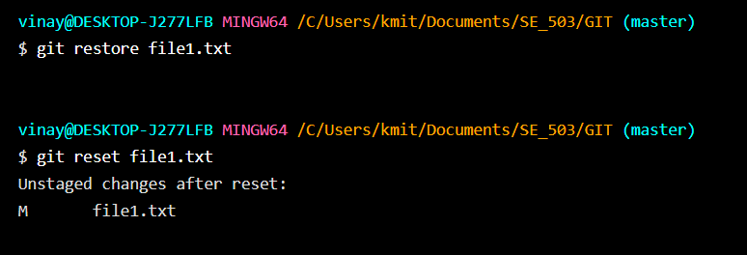

3. You made a commit but typed the wrong commit message. You haven’t pushed it yet. How do you fix it?

4. You want to view the commit history of the current branch in a readable format. What Git command should you use?

5. After cloning a repo, how can you set your name and email globally for all Git repositories?

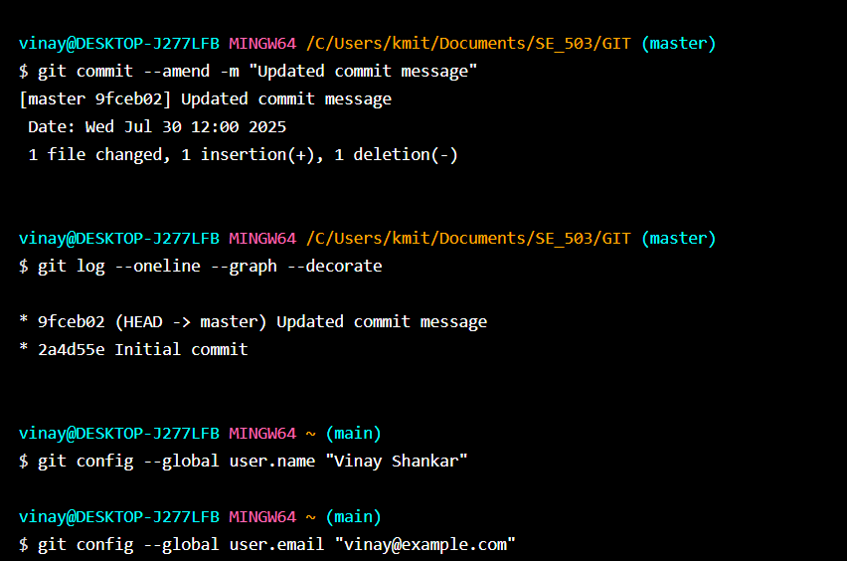

6. You’ve made some edits to your files but haven’t staged them. How can you view the changes?

7. You’re on the main branch but need to switch to feature/login. What command do you

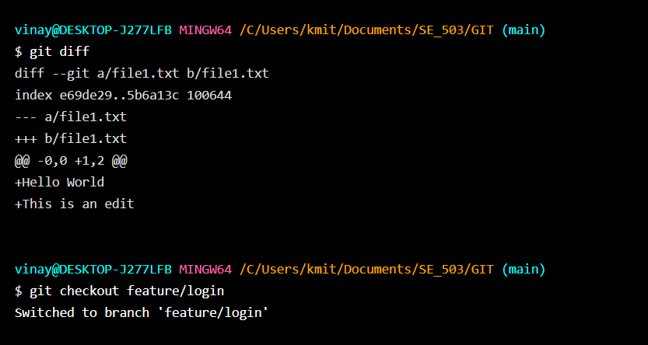

8. You deleted the feature-ui branch by mistake. You haven’t pushed the deletion. How

9. You’ve made some commits locally and now want to upload them to the remote repository. What do you run?

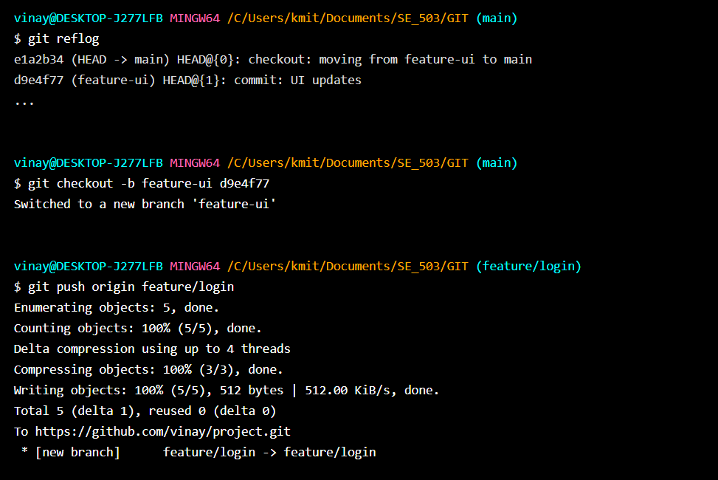

10. How can you fetch the latest changes from the remote repository without merging them automatically?

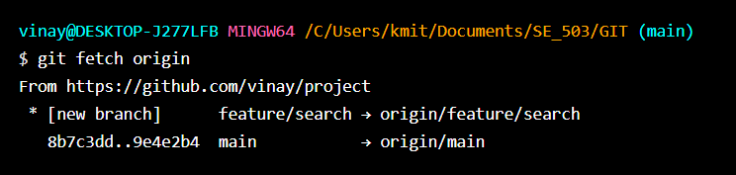

11. You’re on the main branch and want to start working on a new feature called search-filter. What command do you use?

12. You committed a file containing an API key and want to completely remove it from the repo's history. What should you do?

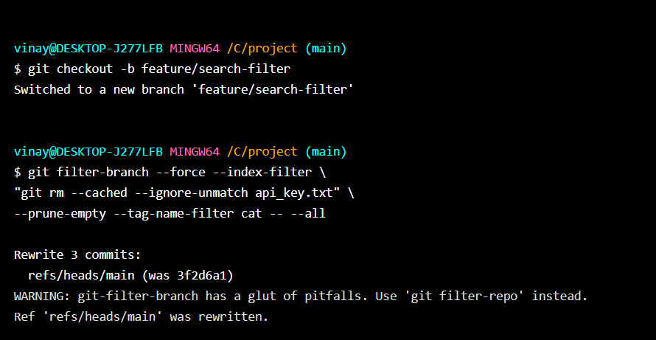

13. You want to see all the branches that exist both locally and on the remote. What

14. You’re on main and want to merge the completed feature/signup branch into it. What command do you use?

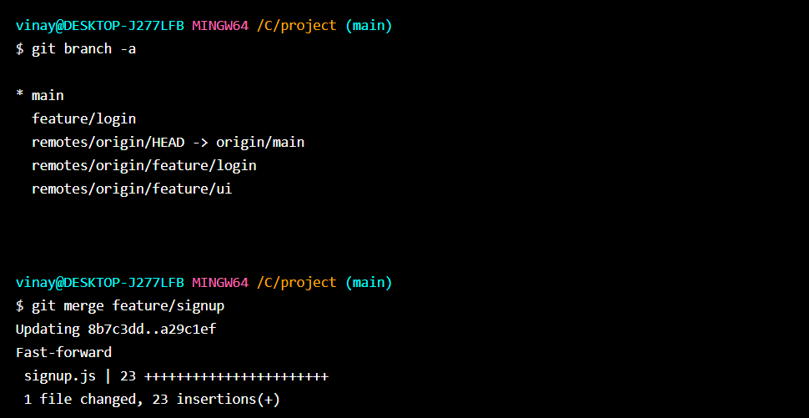

15. You tried to merge two branches and Git reported a conflict in app.js. What are the general steps to resolve it?

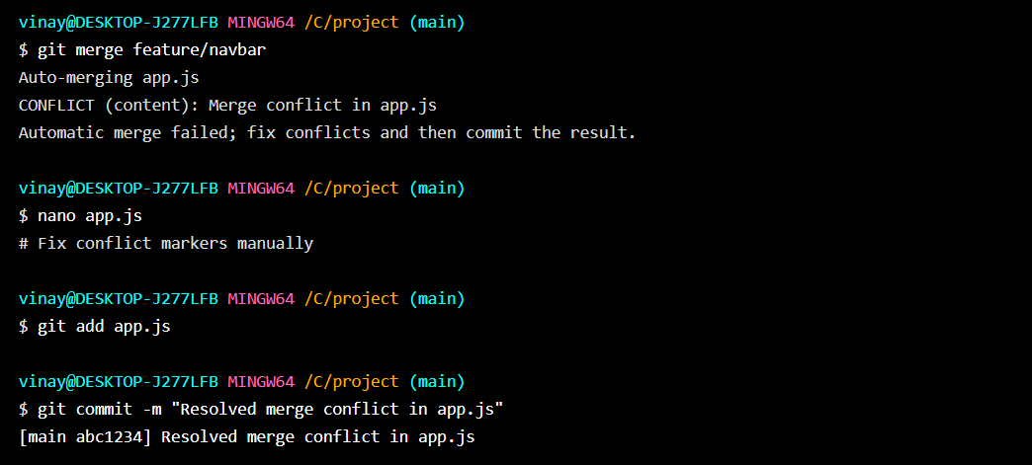

16. You don’t want Git to track changes to .log files or node_modules/. How do you achieve this?

17. You're investigating a bug and want to know who last changed line 25 in script.py. What command do you use?

18. You’re in the middle of working on a file but need to switch branches quickly. What do you do to save your work?

19. You previously ran git stash and now want to restore those changes. What command do you use?

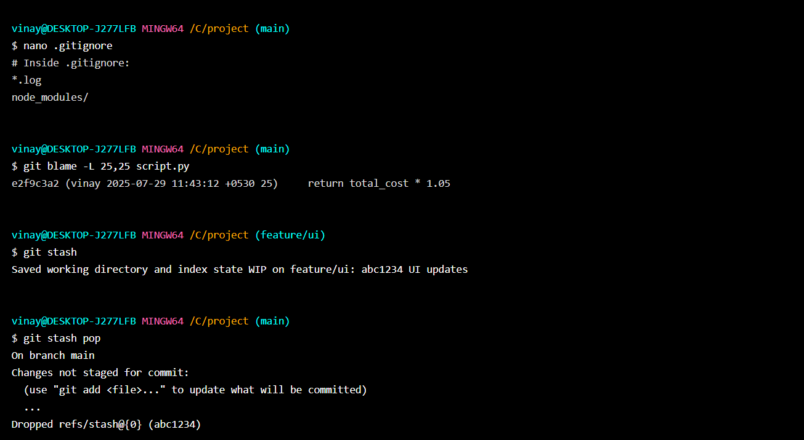

20. The feature/test branch is no longer needed. How do you delete it locally?

21. You just merged the feature-ui branch into main. You want to clean up your local branches. How do you safely delete feature-ui?

22. You created a branch feature-experiment, made some changes, but now realize the code is no longer needed. You want to delete it, even though it hasn’t been merged. What command will you use?

23. You're currently on the feature-login branch and want to delete feature-ui. What must you ensure before running the delete command?

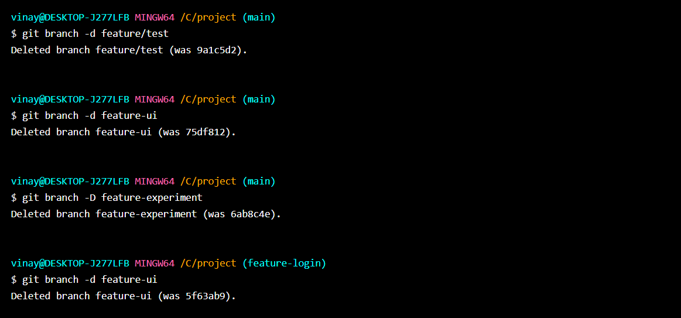

24. You want to delete bugfix-footer, but you're unsure if it's been merged. What should you do before deleting it?

25. You finished working on feature-a, feature-b, and feature-c. All have been merged into main. How do you delete them in one command?

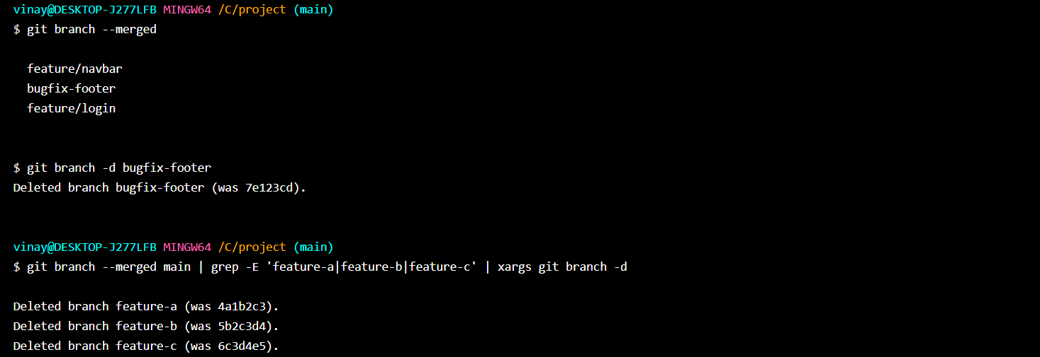

**Scenario based questions on working with remote repository using Git commands**

### 1. Specify the git command when you're starting work on a project and need to clone a remote repository to your local machine.

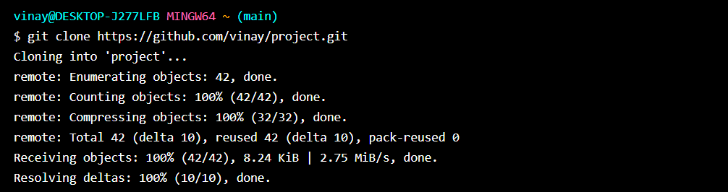

### 2. Specify the git command if you want to see the remotes that are connected to your local repository.

### 3. Specify the git command if you want to add a new remote repository to your local repository.

### 4. Specify the git command to remove a remote repository from your local configuration:

### 5. Specify the git command if you want to rename an existing remote:

